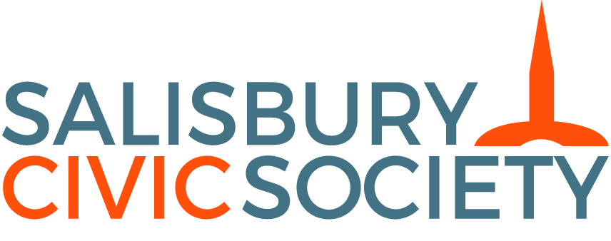

Press Release 10 November 2017
Annual Open Meeting

The Maltings Redevelopment:
First Public Presentation and Consultation

Tuesday November 21st Alamein Suite, City Hall, Salisbury

Times: 6.30pm pre-meeting drinks and displays; Talks start 7.30pm; Close 9.15pm
Admission & Drinks: free of charge, all are welcome

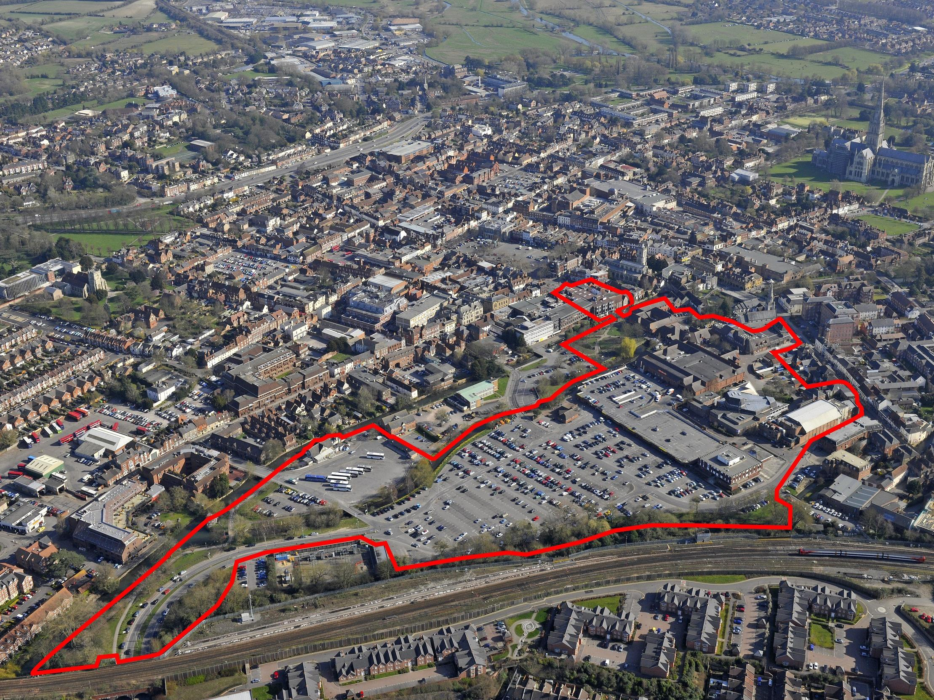

Salisbury Civic Society’s aims include enhancing the built environment and landscape setting of the area and the Annual Open Meeting run by the Society is one of many activities through which it seeks to achieve this aim. The Open Meetings, held every year since 1997, are designed to draw attention to a topic which could bring benefits to city and district, and are open to all free of charge.
This year’s Annual Open Meeting will be on “The Maltings Redevelopment”, and will present the emerging plans for the redevelopment of the Maltings and Central Car Park in Salisbury.
For most people this will be the first opportunity to learn about the proposed shape of this long-running project.
The developers TH Real Estate along with the development managers Rivington Land and the architects Haskoll, will outline the principles of development for the site.
Richard Walters, Head of Major Projects for Wiltshire Council, will also speak.
After the talks, there will be plenty of time for questions and discussion.
This presentation marks the start of pre-planning consultation with an application to be submitted next year, on completion of further consultation (including with the wider community) that will incorporate feedback from that consultation into the scheme design.

Further Information
For further information or to arrange speaker press and photo opportunities during the pre-meeting drinks please contact:
Neil Beagrie
Publicity Officer
Salisbury Civic Society
www.salisburycivicsociety.org.uk
email: neil@beagrie.com tel: 01722 324925
Mobile: 07973300869

